14.48: The cylindrical rod has mass 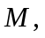 radius 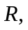 and length with a density that is proportional to the square of the distance from one end, 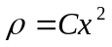.
a)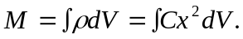 The volume element 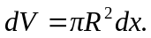 Then the integral becomes 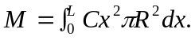 Integrating gives 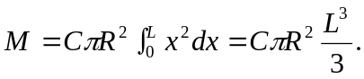 Solving for 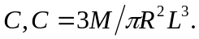
b) The density at the 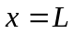 end is 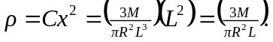 The denominator is just the total volume 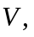 so 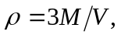or three times the average density, 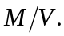 So the average density is one-third the density at the end of the rod.

